Combined Surgical and Orthodontic Treatment
Contemporary Orthodontics-4th Ed. (Proffit)- Chapter 19
Ali Habiballah Hassan BDS, Cert. Orthod. MPHE, PhD
www.kau.edu.sa/aakbr

Introduction
Orthognathic Surgery: Surgical repositioning of the jaws

Indications:
1- Severe skeletal discrepancies (Class II, III, vertical problems) that cannot be fixed by neither growth modification nor camouflage
2- Facial Esthetics
3- When growth modification cannot be achieved

Please remember:
Surgery is not a substitute for orthodontics. Instead, it must be properly coordinated with orthodontics
and other dental treatment to achieve good overall results.

In the border line cases, careful decision should be made between camouflage treatment and Surgery

Envelope of Discrepancy: determine the limits of tooth movement alone, growth modification and surgery. The limits vary by:
- the amount of tooth movement required
- The age of the patient

Envelopes are not symmetrical:
More potential to retract than procline teeth
More potential to extrude than intrude
More potential to setback the lower jaw than to advance it

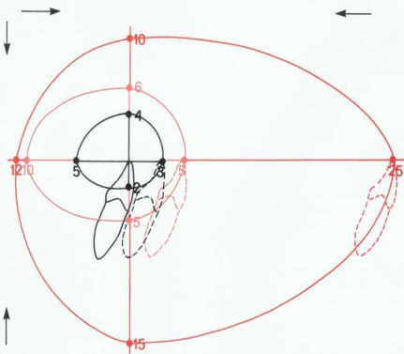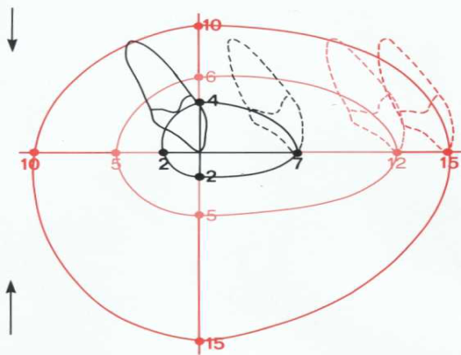

Timing of Surgery:

- Usually done when all growth is complete
- Assessed by superimposition of serial lat cephs
- Can be performed when growth is not yet complete in cases of psychosocial problems or great severity when function is compromised (i.e. breathing, chewing)

Surgical Techniques
- Bilateral sagittal split osteotomy (BSSO)
- Genioplasty
- Le Fort I
- Le Fort II
- Le Fort III

Le Fort III
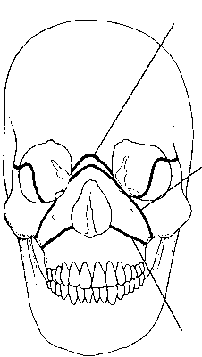Le Fort I

Types of orthognathic Surgery:

- Correction of A-P relationships:
- maxillary advancement
- retraction of anterior maxillary segment
- mandibular advancement
- mandibular setback
- double jaw surgery

- Correction of Vertical Relationships:
- maxillary impaction/intrusion
- maxillary extrusion
- mandibular ramus surgery

- Correction of Transverse Relationships:
- surgically assisted maxillary expansion
- surgically assisted mandibular expansion

- Correction of Asymmetries:
- Maxilla
- Mandible
- maxilla and mandible

When to decide Surgery and not extraction?

Important Considerations
- Chief Complaint: dental vs facial complaint: eg: prominent chin vs. protruded teeth.
- Facial Appearance: Camouflage is done when facial beauty can be improved via lip retraction without any chin surgery.
- Severity of the skeletal and dental discrepancies:
- Sever discrepancy: surgery.
- Mild to moderate: camouflage.

- Presence of functional shift:
Very important to check for forward functional shift at the time of examination. Presence of such shift may decrease the severity of the malocclusion.

- Anatomy of the Symphysis:
- Thin and narrow symphysis in Class III malocclusion might limit the retraction of lower incisors
- Family History:

Maxillary vs Mandibular Surgery?

- The two Jaws can be moved three dimensionally to achieve the objectives.
- Adjunctive facial procedures are sometimes needed
- Two Jaw Surgery is the best approach for many cases:
For better stability
Most cases have vertical components
To avoid double chin
20% of the cases are combined

Steps of Ortho-Surgical Tx:
- Proper Diagnosis and Treatment Planning
- Discussion of TP with the Surgeon
- Explanation of Treatment Plan
- Presurigcal Orthodontics
- Orthognahtic Surgery
- Finishing and Detailing

Proper Diagnosis/ Treatment Planning:
Facial Examination and photographic analysis
Cephalometric Analysis
Surgical Prediction
Model Occlusal Analysis

Computer Simulation of Alternative Treatment Outcome:
Computer image prediction helps the patient to decide between camouflage and surgery planning surgical treatment. Current prediction methods are more reliable for profile changes than frontal changes
Model Analysis/Surgery
Simulate/Predict surgery on the models
Prepare surgical splint

Outline for Treatment Planning
- A-P relationships Maxillary deficiency/protrusion
Mand prognathism/deficiency
- Vertical relationships: Open bite
Deep bite

- Transverse relationships: Crossbite/ Relative CB before surgery:

Treatment:
Dental expansion
Surgically assisted expansion
Expansion During surgery
- Amount of Deficiency

- Asymmetries Cant of occlusal plane
Mandible/chin deviation
6- Intrarch problems
a. Incisors: Proclined/Nonral/Retroclined
b. Crowding: needs extraction/ without extraction
c. Curve of Spee: Leveled or not
d. Expansion: needed or not

7- Genioplasty: needed or not
8- Nose/lip relationship - Rhinoplasty needed or not.

Pre-Surgical Orthodontics:
- Level upper and lower arches
- Resolve Spacing or crowding
- Establish coordinated transverse dimensions
- Removal of dental compensation (Establish normal inclination of incisors) is one key to successful Tx, which often requires extraction of teeth
- Preparation for Surgery
- Removal of third molars 6 months before mandibular osteotomy
- Check for any TMJ problems
- Manipulate models mounted in an articulator to check for interferences and occlusion (Model Surgery)
- Splint fabrication (1 or 2 splints)

Esthetic and Psychosocial Considerations in Orthognathic Surgery:
- Data shows a high prevalence of psychological distress (15%-37%), depending on the subscale among those who seek orthognahtic surgery.
- Those who accept a recommendation for surgical treatment see themselves as less normal than those who decide against treatment, even though cephalometric data for the two groups are similar.
- Changes in the position of the chin and nose are likely to have a greater impact on facial esthetics than changes limited to the lips
- The effect of orthognathic surgery on the lower face extends the esthetic impact of treatment considerably.
- If esthetics is a major goal of treatment, changes in the nose, and perhaps other changes in facial soft tissue contours that could be produced by facial plastic surgery should be considered in the treatment planning.
- Psychological Reactions to Orthognathic Surgery: About 90% of patients who undergo orthognathic surgery report satisfaction with the outcome
- Over 80% (a more revealing number) say that, knowing the outcome and what the experience was like, they would recommend such treatment to others and would undergo it again.
- Few patients have great difficulty in adapting to significant changes in their facial appearance, especially at older age (Young age??)
- Major esthetic changes in older adults may not be desirable.

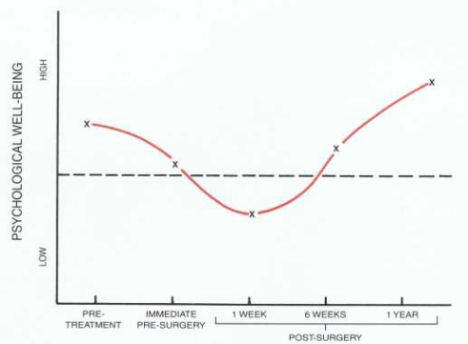
Psychological Reaction of patients during Surgery

Correction of Anteroposterior Relationships:

Maxillary Surgery
- The maxilla can be moved forward if bone grafts are interposed posteriorly to help stabilize the new position.
- Posterior movement of the entire maxilla is not easily achieved because other skeletal components that normally support the maxilla interfere with moving it back.
- However, this difficulty is overcome by segmenting the maxilla so that only the anterior portion is retracted
- The LeFort I downfracture procedure almost always is used now to reposition the maxilla.
- If the maxilla is advanced, a graft in the retromolar area or at a step created in the lateral wall usually is required. Various materials, including autogenous and freeze-dried bone and alloplastic substances, can be used.

- Retraction of the anterior segment is achieved by removal of a premolar, segmentation, and movement of the anterior segment into the space created . Although it is technically possible to move the entire maxilla posteriorly, rarely is this necessary.

Mandibular Surgery:
- The mandible can be moved anteriorly or posteriorly in the sagittal plane with relative ease.
- Extreme advancement may create stability problems associated with neuromuscular
adaptation and stretch of the investing soft tissues.

Mandibular advancement:
- Currently, the bilateral sagittal split osteotomy (BSSO) of the mandibular ramus, performed from an intra-oral approach, is the preferred procedure for most patients who need mandibular advancement.
- The greatest drawback of the sagittal split is altered sensation post-operatively. Paresthesia over the distribution of the inferior alveolar nerve almost always is present immediately after surgery. Usually this disappears in 2 to 6 months, but 20% to 25% of patients have some degree of long-term altered sensation.

Mandibular Setback:

Reduction of mandibular prognathism can be accomplished by one of two techniques performed in the ramus, each having advantages and disadvantages.

- The BSSO discussed previously can be used to move the mandible posteriorly as well as anteriorly. It is widely used for setbacks because of excellent control of the condylar segments and because osteosynthesis screws can be employed for fixation.

- The transoral vertical oblique ramus osteotomy (TOVRO):
- Is limited to mandibular setback and requires full-thickness overlapping of the segments.
- This procedure requires less time than the sagittal split osteotomy
- Is less likely to produce neurosensory changes.
- But jaw immobilization after surgery is necessary
- Control of the condylar fragment can be difficult.

Correction of Vertical Relationships
- Maxillary Surgery
- Mandibular Surgery

Correction of Asymmetry
Genioplasty in Orthognathic Treatment
Integration of Orthognathic and Other Facial Surgery
